MAP OF ROUTE

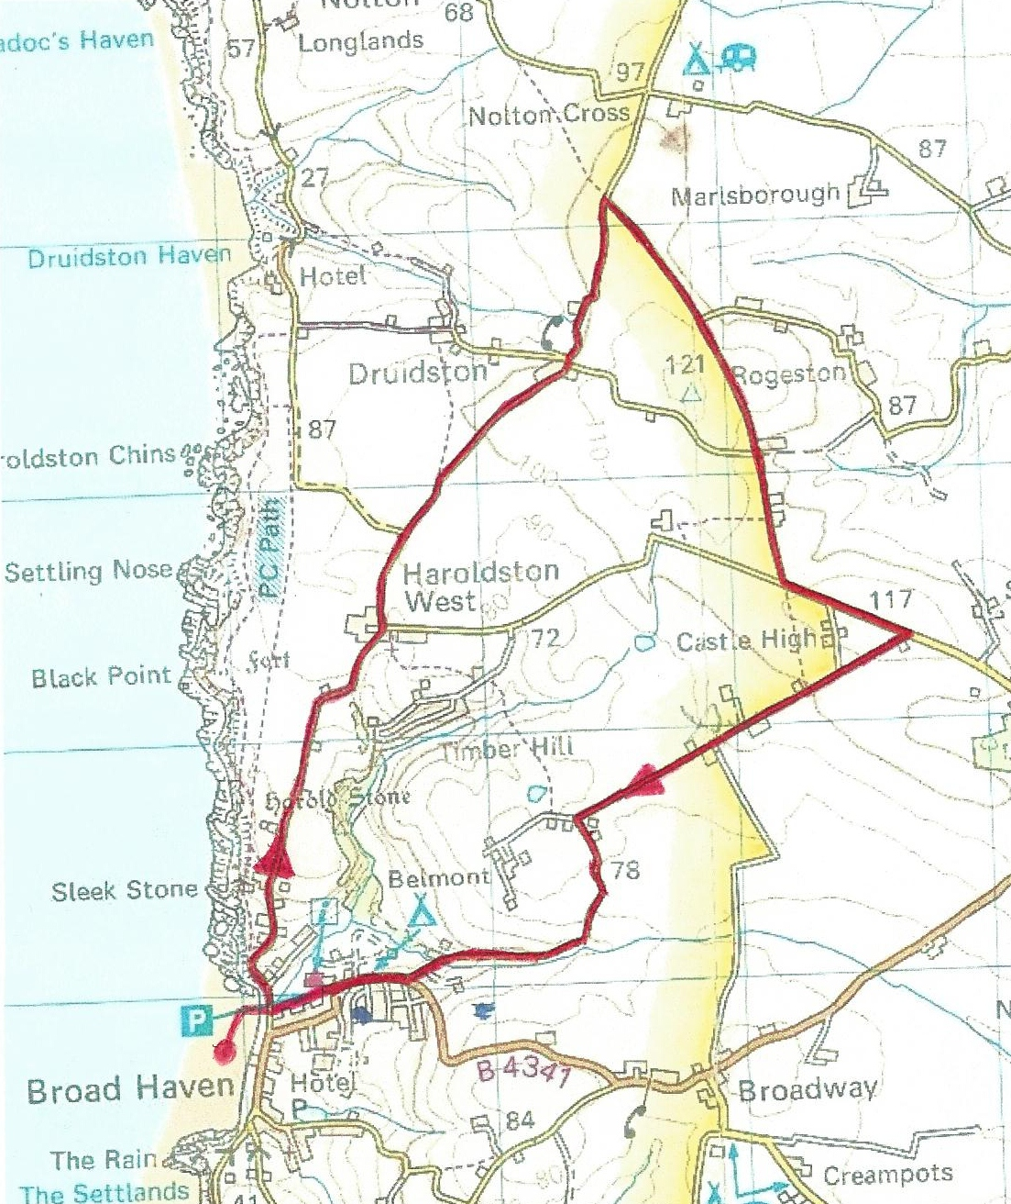

RUN DESCRIPTION

0 km |  | Start on Broad Haven beach opposite the Ocean Café/bar. Head north over pebbles and over bridge onto road B4341 towards Haroldston Hill
0.14 km |  | Run north up Haroldston Hill
1.04 km |  | Continue on B4341.
4.01 km |  | Turn right onto Leys Lane.
4.02 km |  | Run south-east on Leys Lane.
5.88 km |  | Road bears east towards Long Lane.
6.26 km |  | Turn right onto Long Lane
9 km |  | Turn right onto Millmoor Way.
9.31 km |  | Turn right into Millmoor Way car park.
9.67 km |  | Cross Coast Road B4341 to beach
9.81 km |  | Finish line on beach

